JALDA SUCHITHRA

**MAILING ADDRESS: EMAIL:**suchithrajalda68@gmail.com H.NO:9-28/2/B, **Mobile No:** 91-9391811668

Mahatma nagar,

Karimnagar,Telangana-505001.

**OBJECTIVE:**

Looking to work in an organization that can provide a variety of opportunities that allow me to expand my skills and knowledge while working towards achieving the organizational goal. A dedicated and detail-oriented individual looking for an entry-level position at a well-reputed organization to gain experience and exposure and expand my knowledge.

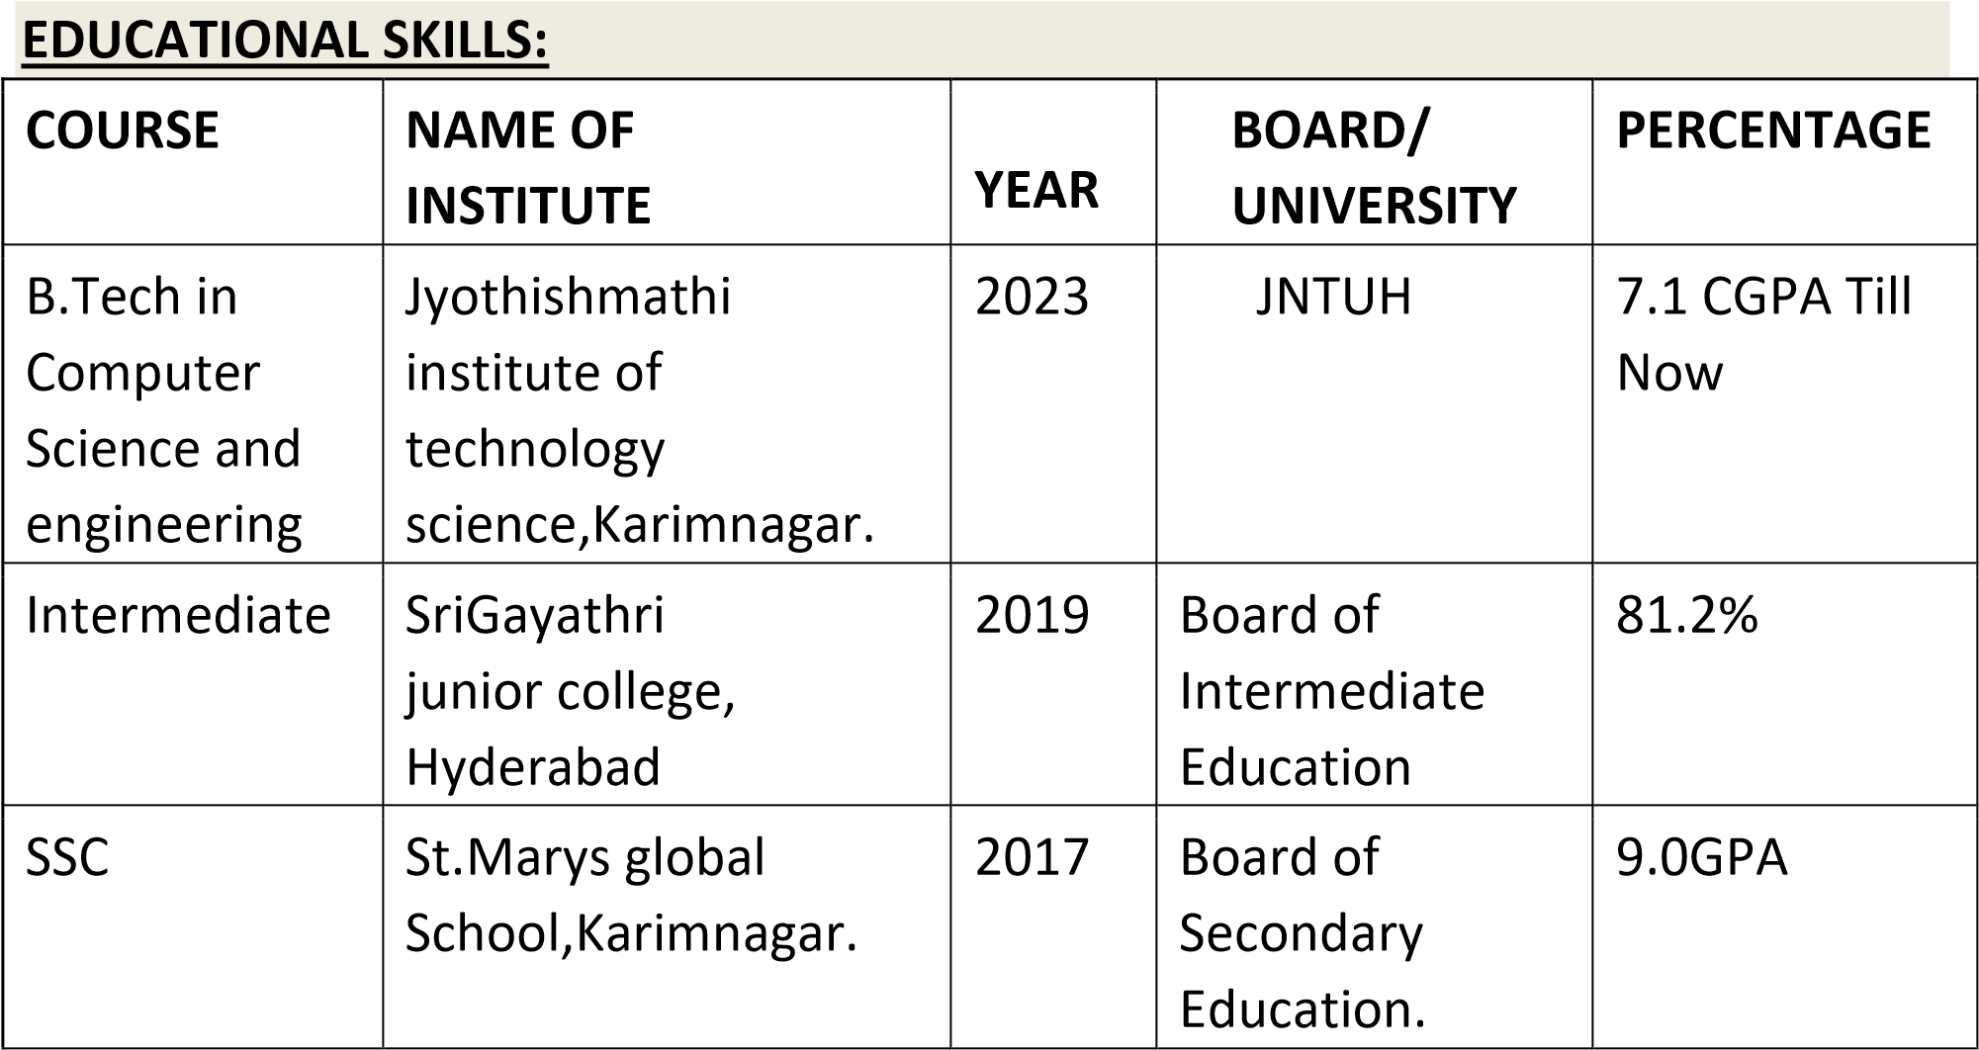

7.2 CGPA

**TECHNICAL SKILLS:**

* Programming skills : basic C, Basic JAVA & python.
* Web technologies : HTML, CSS, JavaScript.
* Operating System : Windows.
* Data Base : DBMS, MYSQL

**Projects:**

* **Real-time intrusion detection system**

Network-based project

This project is based on supervised machine learning methods for developing an efficient and flexible system that can detect intrusions from the data that is received in real time

* **An efficient spam detection for IOT devices**

The proposed framework detected the spam parameters of IOT devices using ML models. The IOT data set used for experiments was pre-processed by using feature engineering procedure. By experimenting the framework with ML models, each IOT appliance was awarded with a spam score. This refined the conditions to be taken for successful working of IOT devices in a smart home

**ACHIEVEMENTS:**

* Python programming- Codetantra.
* Html- udemy, online
* Certificate of Appreciation of Digital Literacy
* Certificate of basic java programming
* Certificate of national level online quiz on Engineering Physics

**PERSONAL DETAILS:**

Name : Jalda Suchithra

Father Name : J. Bhoomeshwar.

Date of Birth : 6nd August 2001.

Age : 22.

Sex : Female.

Nationality : Indian.

Languages known : English, Telugu, Hindi.

|  |  |
| --- | --- |
| Hobbies | : Listening to music, Mandala art. |
| **DECLARATION:** |  |

I here by declare that the information given is true up to my knowledge.

Place: Karimnagar.

Date: 6-12-2022. **JALDA SUCHITHRA**